**Pune Institute of Computer Technology**

**Department of Computer Engineering**

(2022- 2023)

# **“Banking App”**

**Submitted to the**

**Savitribai Phule Pune University**

**In partial fulfillment for the award of the Degree of**

**Bachelor of Engineering**

**in**

**Computer Engineering**

**By**

1. **Sanket Kulkarni 41146**
2. **Sourabh Kumbhar 41147**

Under the guidance of

**Prof. Madhuri Mane**

**CONTENTS**

|  |  |  |
| --- | --- | --- |
| **Sr. No** | **TITLE** | **Page no** |
| **1.** | Introduction | **3** |
| **2.** | Problem Statement | **3** |
| **3.** | Objectives | **3** |
| **4.** | Theory | **3** |
| **5.** | Conclusion | **6** |
| **6.** | References | **6** |

**Introduction**

Mobile banking offers a lot of customer satisfaction by giving good security, easy access and plentiful applications in mobile software to do the transaction easily in less period of time. You can access your account from anywhere in the world, so it benefits customer's time a lot and easily access of banking. It allows to access financial transactions through mobile phone from anywhere in the world. It is the kind of financial services where customers get information, account enquiry, transfer and remittance of funds, balance statement information, account management etc.

Technology can be organized for the combination of people, communication networks and data resources that collects information in an organization. Mobile banking and online banking frees saves there time without calling the branches for the transactions.

**Problem Statement**

Create an application for Bank using spinner, intent

1. Form 1: Create a new account for customer
2. Form 2: Deposit money in customer account.
3. Link both forms, after completing of first form the user should be directed to second form
4. Provide different menu options

**Objective**

Implement an application for Bank

**Theory**

App components are the essential building blocks of an Android app. Each component is an entry point through which the system or a user can enter your app. Some components depend on others.

There are four different types of app components:

* Activities
* Services
* Broadcast receivers
* Content providers

Each type serves a distinct purpose and has a distinct lifecycle that defines how the component is created and destroyed.

**Activities**

An *activity* is the entry point for interacting with the user. It represents a single screen with a user interface. For example, an email app might have one activity that shows a list of new emails, another activity to compose an email, and another activity for reading emails. Although the activities work together to form a cohesive user experience in the email app, each one is independent of the others. As such, a different app can start any one of these activities if the email app allows it.

**Services**

A *service* is a general-purpose entry point for keeping an app running in the background for all kinds of reasons. It is a component that runs in the background to perform long-running operations or to perform work for remote processes. A service does not provide a user interface. For example, a service might play music in the background while the user is in a different app, or it might fetch data over the network without blocking user interaction with an activity. Another component, such as an activity, can start the service and let it run or bind to it in order to interact with it.

**Broadcast receivers**

A *broadcast receiver* is a component that enables the system to deliver events to the app outside of a regular user flow, allowing the app to respond to system-wide broadcast announcements. Because broadcast receivers are another well-defined entry into the app, the system can deliver broadcasts even to apps that aren't currently running.

**Content providers**

A *content provider* manages a shared set of app data that you can store in the file system, in a SQLite database, on the web, or on any other persistent storage location that your app can access. Through the content provider, other apps can query or modify the data if the content provider allows it.

**Intent**

An Intent provides a facility for performing late runtime binding between the code in different applications. Its most significant use is in the launching of activities, where it can be thought of as the glue between activities. It is basically a passive data structure holding an abstract description of an action to be performed.

**Spinner Intent**

Spinners provide a quick way to select one value from a set. In the default state, a spinner shows its currently selected value. Touching the spinner displays a dropdown menu with all other available values, from which the user can select a new one.

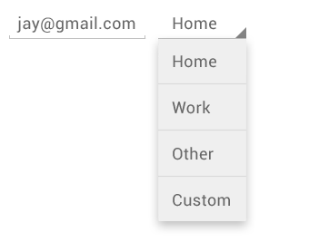

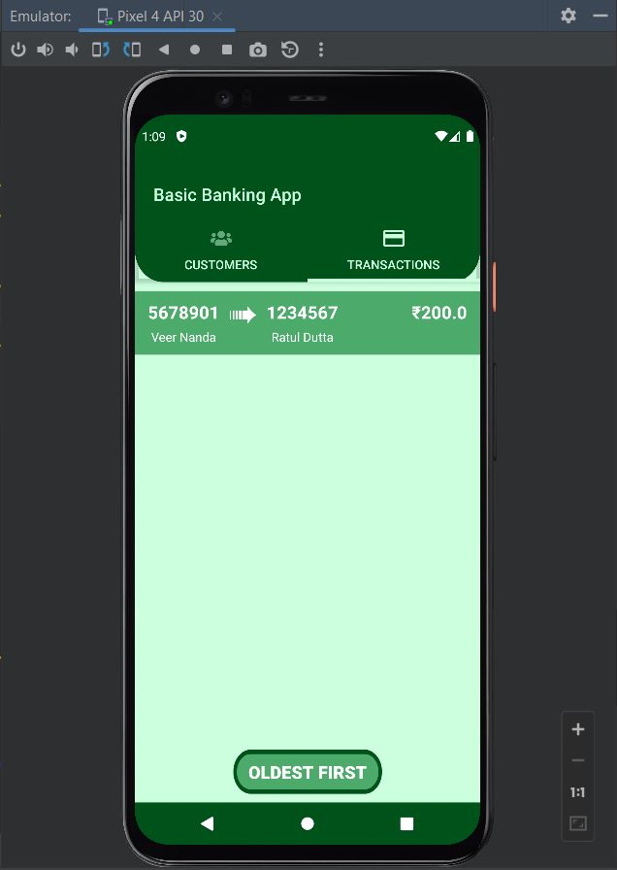**Output**

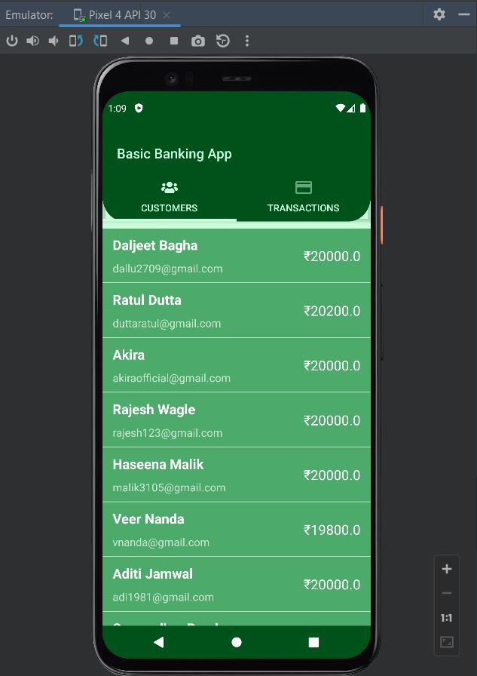

**Conclusion**

Thus, We have implemented android application for bank

**References**

* <https://developer.android.com/>
* <https://www.javatpoint.com/android-tutorial>